**SUPPLY CHAIN DASHBOARD**

**Introduction:**

In today's competitive business environment, efficient supply chain management is essential for a company's prosperity. This report explores the concept of supply chain analytics, where in-depth analysis of data sets helps businesses achieve operational excellence and make strategic decisions.

To improve customer satisfaction, optimize productivity, and stay ahead of the competition, companies must prioritize monitoring their customer delivery performance. By closely examining the delivery process and analyzing relevant metrics, businesses can gain valuable insights into their effectiveness, pinpoint areas for improvement, and proactively address potential future problems.

This data set, provided by DataCo Global, contains information on the company's supply chain operations, including customers, orders, distribution, shipping, and products, spanning the years 2015 to 2018. With approximately 180,519 data points, the data set is on the smaller side.

**Objective:**

To provide actionable insights and strategic recommendations based on a comprehensive analysis of the DataCo Supply Chain dataset, enabling stakeholders to:

1. Identify key trends and patterns in supply chain operations.
2. Optimize processes related to inventory management, logistics, and supplier performance.
3. Support informed, data-driven decision-making across the organization.

This objective focuses on leveraging data insights to drive operational efficiencies, improve decision-making processes, and ultimately enhance the overall performance of the supply chain.

**Inferences/ Findings:**

**Report for Chief supply Chain Officer (CSCO)**

**Count of Customers by Delivery Status and Shipping Mode**

**Insight:**

**Late Deliveries:** Approximately 54% of customers experienced late deliveries, which indicates a significant portion of customers are affected by this issue

**Order Cancellations**: A smaller percentage, 2.6%, canceled their orders, which could be linked to dissatisfaction or inconvenience caused by late deliveries or other logistical issues.

The insight suggests a need to investigate and potentially improve logistics processes to enhance delivery reliability and customer satisfaction. It provides a clear direction for addressing inefficiencies in logistics based on the data visualized.

**Shipping Day Difference by Shipping Mode**

**Insight:**

**First class and same day customers:** Despite being high-paying customers, they are experiencing delays of one day. This suggests a potential area for improvement to enhance customer satisfaction and maximize revenue generation.

**Second class delivery mode:** There is a significant lead time between the order and shipment day, sometimes resulting in delays of up to 4 days. This indicates a specific area of concern that may impact customer satisfaction and operational efficiency.

**Standard class delivery mode:** Approximately 50% of customers receive early deliveries, which is a positive aspect indicating efficient performance in this delivery mode.

Overall, this insight effectively utilizes the graph to identify performance issues and strengths across different delivery modes. It provides actionable information that can help prioritize improvements and optimize delivery operations to better meet customer expectations and business goals.

**Top Selling Products and their Revenue:**

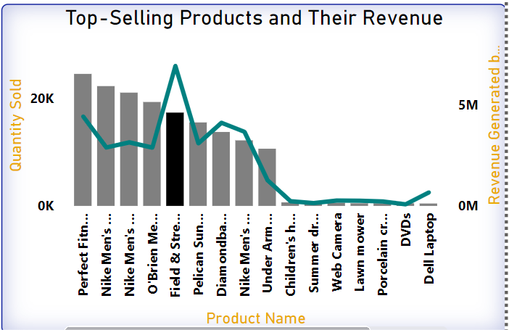

**Insight:**

The price range for the top 10 sold products is between $30 and $300. 'Perfect Fitness Perfect Rip Deck' is the top-selling product in the category "Cleat." However, the revenue generated by 'Field and Stream Sportsman 16 Gun Fire Safe' is 56% higher than that of the top-selling product.

This visualization aids in inventory management and provides valuable insights into customer purchasing behaviors.

**Average Shipping Day Difference by the Year 2015 – 2018**

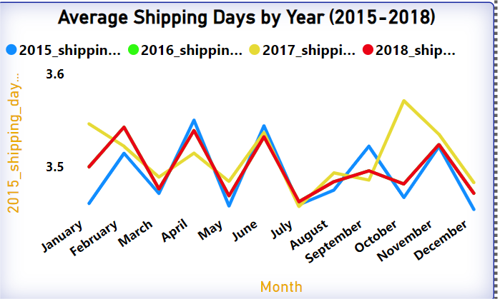

**Insight:**

The graph illustrates that there has been no significant improvement in the average shipping day difference from 2015 to 2018. To enhance its market competitiveness, the company needs to focus on improving its supply chain efficiency and reducing shipping delays.

**Customer Country Analysis:**

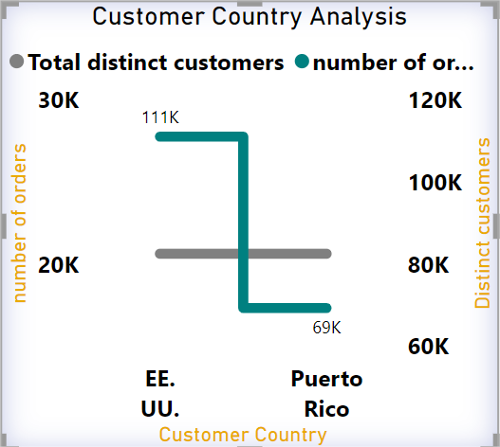

**Insight:**

EE.UU stands for the United States of America. The dataset includes customers from two countries: EE.UU and Puerto Rico. Although both countries have an equal number of registered customers, the demand for products is significantly higher in EE.UU, with a total demand of 42,000 units.

Recommendation:

To capitalize on this demand and seize market opportunities, it is recommended to strengthen the distribution network in EE.UU. This will help fulfill the high demand efficiently and improve our market presence.

**Report for Chief Executive Officer (CEO)**

**Profit BY the Year 2015 to 2018**

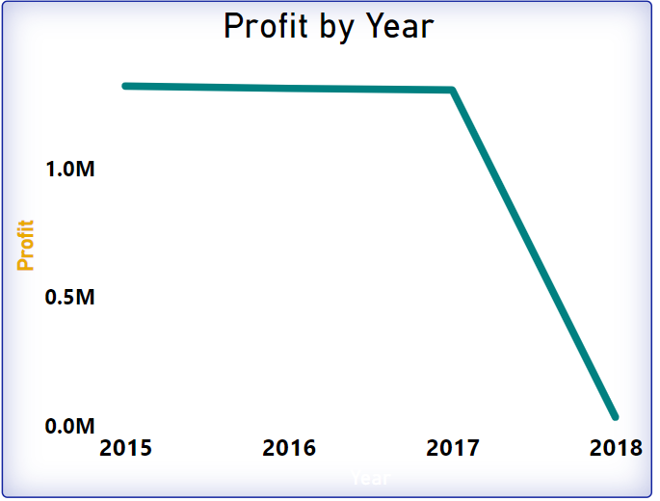

**Insight:**

The visualization indicates a slight decrease in the company's profit from 2015 to 2017, with revenue decreasing by only 1% during this period. Cannot infer the profit for the year 2018 because the data is not sufficient. Despite this, the company successfully increased its customer count by 5,000.

This insight into the company's financial metrics suggests that the primary focus currently is on increasing customer footfall.

**Order cancellation by Order country**

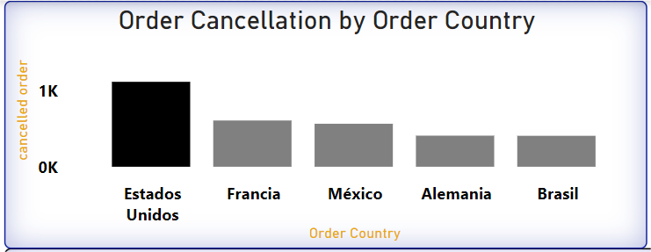

**Insight:**

The country "Estados Unidos" canceled approximately 1,000 orders, followed by "Francia." The primary reasons for these cancellations could be logistics issues and stockouts. It is crucial to focus more on these countries to mitigate order cancellations, as they can significantly decrease revenue and increase customer dissatisfaction.

**Category Sales and Pricing Overview**

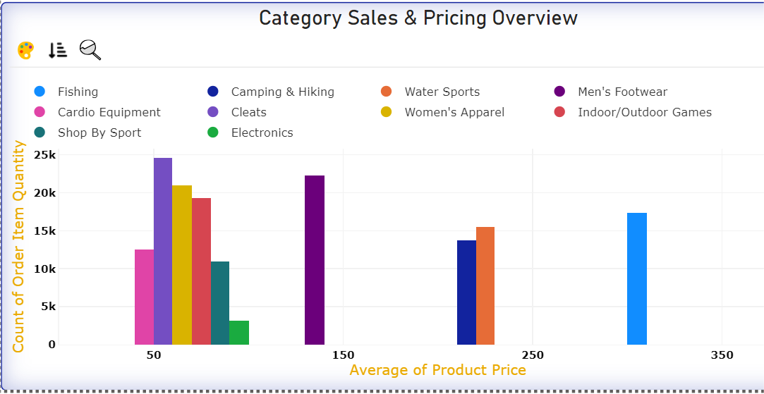

**Insight:**

The graph indicates that the most popular categories are cleats, women's apparel, games, and men's footwear. The cleats category has the highest sales, with 250,000 units sold. Additionally, the most popular products fall within the price range of $40 to $160.

This visualization is valuable for understanding customer purchasing behavior and aiding in inventory management. It helps identify high-demand categories and optimal price ranges, enabling better stock planning and pricing strategies.

**Market Share Distribution by Order Region**

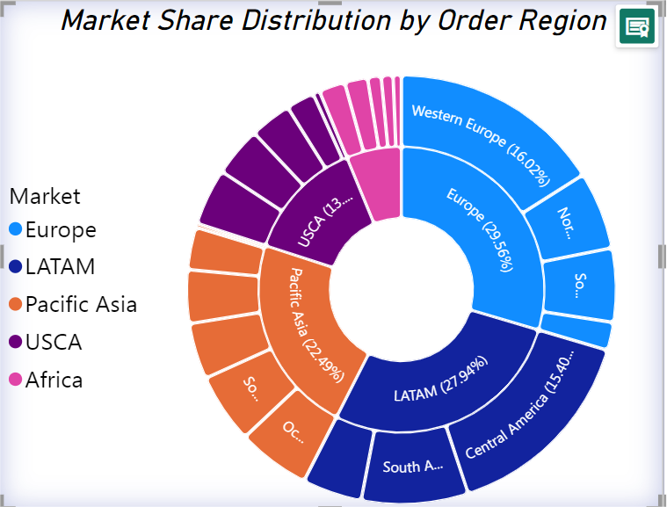

**Insight:**

The LATAM region represents Latin America, and the USCA region represents the United States and Canada.

Together, the LATAM, Europe, and Pacific Asia regions account for over 80% of all orders, with Europe being the dominant region. Within Europe, the Western Europe subregion processes over 50% of the orders.

This visualization is valuable for resource allocation and strategic planning.